



**2024-25**

**COMPUTER ENGINEERING**

**Data Structure lab**

**ECS-301**

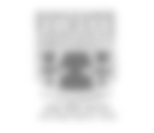

**SUBMITTED BY:**

**Mr. Ram Singar Verma**

Name **:** avnish srivastava

Roll no. : 238209

Branch : computer engineering

Year : 2nd

Subject : data structures using c

Write a program to insertion and deletion of element on array.

#include <stdio.h> int main() {

int i, a[5], n;

printf("Insert elements into the array:\n"); for (i = 0; i < 5; i++) {

scanf("%d", &a[i]);

}

printf("Enter the element to delete from the array: "); scanf("%d", &n);

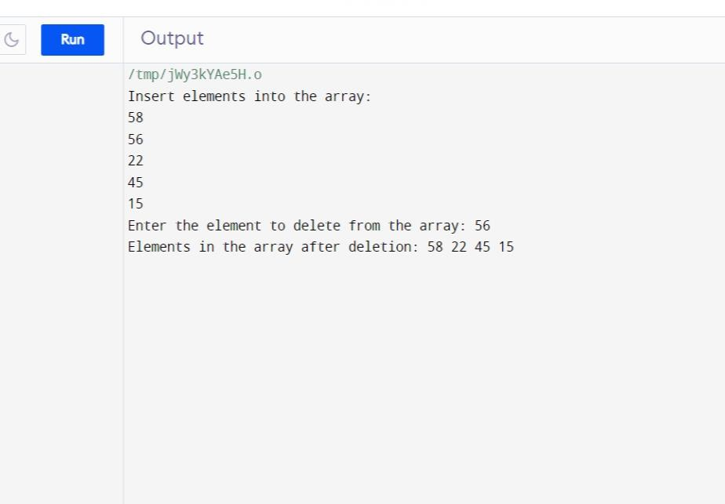printf("Elements in the array after deletion: "); for (i = 0; i < 5; i++) {

if (n != a[i]) {

printf("%d ", a[i]);

}

}

printf("\n"); return 0;

}

# Write a program to implement Stack operation using an array.

#include <stdio.h> #define MAX_SIZE 10 int stack[MAX_SIZE]; int top = -1;

void push(int element) {

if (top == MAX_SIZE - 1) {

printf("Stack Overflow\n");

} else {

stack[++top] = element;

printf("Element %d pushed to stack\n", element);

}

}

int pop() {

if (top == -1) {

printf("Stack Underflow\n"); return -1;

} else {

int element = stack[top--];

printf("Element %d popped from stack\n", element); return element;

}

}

void display() { if (top == -1) {

printf("Stack is empty\n");

} else {

printf("Elements in the stack:\n"); for (int i = top; i >= 0; i--) {

printf("%d\n", stack[i]);

}

}

}

int main() {

int choice, element;

do {

printf("\nStack Operations:\n"); printf("1. Push\n");

printf("2. Pop\n");

printf("3. Display\n"); printf("4. Exit\n");

printf("Enter your choice: "); scanf("%d", &choice);

switch (choice) { case 1:

printf("Enter the element to push: "); scanf("%d", &element);

push(element); break;

case 2:

element = pop(); if (element != -1) {

printf("Popped element: %d\n", element);

}

break; case 3:

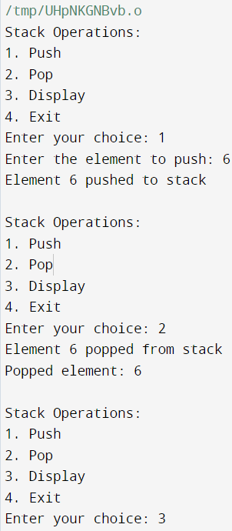display(); break;

case 4:

printf("Exiting...\n"); break;

default:

printf("Invalid choice\n"); break;

}

} while (choice != 4);

return 0;

}-

# Write a program to evaluations of postfix arithmetic expression.

#include <stdio.h>

int main() {

int array[100], n, c, d, swap;

printf("Enter the number of elements: "); scanf("%d", &n);

printf("Enter %d integers:\n", n); for (c = 0; c < n; c++) {

scanf("%d", &array[c]);

}

// Bubble sort

for (c = 0; c < (n - 1); c++) {

for (d = 0; d < (n - c - 1); d++) { if (array[d] > array[d + 1]) {

// Swap elements swap = array[d];

array[d] = array[d + 1]; array[d + 1] = swap;

}

}

}

printf("Sorted list in ascending order:\n"); for (c = 0; c < n; c++) {

printf("%d\n", array[c]);

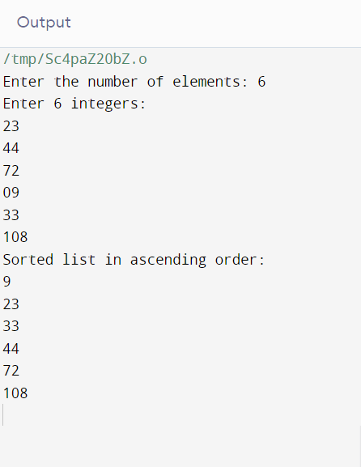}

return 0;

}

# Write a program to implement Heap Sort algorithm.

#include <stdio.h>

void heapsort(int[], int); void heapify(int[], int); void adjust(int[], int);

int main() {

int n, i, a[50];

printf("Enter the limit: "); scanf("%d", &n);

printf("Enter the elements: "); for (i = 0; i < n; i++)

scanf("%d", &a[i]);

heapsort(a, n);

printf("\nThe Sorted Elements Are:\n"); for (i = 0; i < n; i++)

printf("\t%d", a[i]); printf("\n");

return 0;

}

void heapsort(int a[], int n) { int i, t;

heapify(a, n);

for (i = n - 1; i > 0; i--) { t = a[0];

a[0] = a[i]; a[i] = t;

adjust(a, i);

}

}

void heapify(int a[], int n) { int k, i, j, item;

for (k = 1; k < n; k++) { item = a[k];

i = k;

j = (i - 1) / 2;

while ((i > 0) && (item > a[j])) { a[i] = a[j];

i = j;

j = (i - 1) / 2;

}

a[i] = item;

}

}

void adjust(int a[], int n) { int i, j, item;

j = 0;

item = a[j]; i = 2 * j + 1;

while (i <= n - 1) {

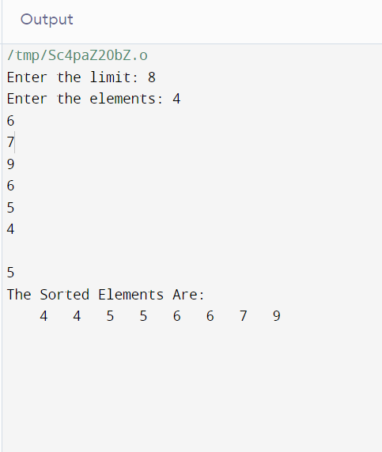if (i + 1 <= n - 1 && a[i] < a[i + 1]) i++;

if (item < a[i]) {

a[j] = a[i]; j = i;

i = 2 * j + 1;

} else {

break;

}

}

a[j] = item;

}

# Write a program to implement Insertion Sort algorithm

#include<stdio.h> int main(){

int i,j,s,temp,a[20];

printf("Enter total elements: "); scanf("%d",&s);

printf("Enter %d elements: ",s); for(i=0;i<s;i++)

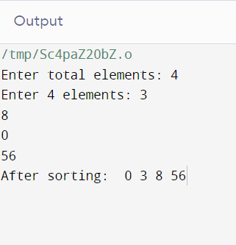scanf("%d",&a[i]); for(i=1;i<s;i++){ temp=a[i];

j=i-1;

while((temp<a[j])&&(j>=0)){ a[j+1]=a[j];

j=j-1;

}

a[j+1]=temp;

}

printf("After sorting: "); for(i=0;i<s;i++)

printf(" %d",a[i]); return 0;

}